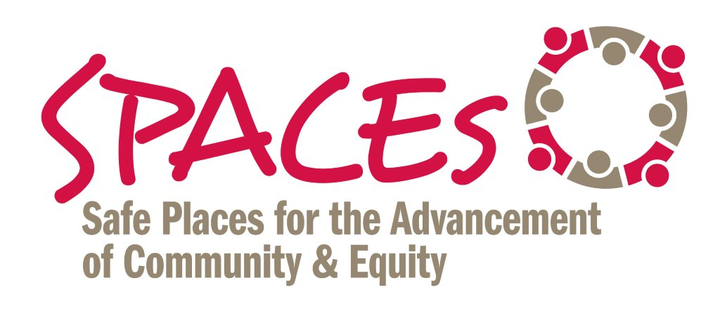
7 STEPS TO REDUCE/INTERRUPT BIAS

STEP # 1 – Increase Your Awareness

- Individual – Take the Implicit Association Test (IAT) at www.withinourlifetime.net

- Organizational – Use the “Racial Equity Toolkit” to Assess Policies, Programs and Budget Issues. You can access the toolkit at http://www.seattle.gov/Documents/Departments/RSJI/RacialEquityToolkit_FINAL_August2012.pdf

STEP # 2 -- Improve decision-making (individual and organizational) by slowing down and removing discretion and ambiguity from decision-making.

STEP # 3 -- Counter Stereotypes (individual and organizational) – use photos and images to counter existing stereotypes.

STEP # 4 -- Practice Perspective Taking (individual) – find creative – and respectful -- ways to experience what it’s like to walk in the shoes of stereotyped or marginalized group.

STEP # 5 – Practice Individuation (individual and organizational) – do regular, in-person, one-on-one meetings with people who: a) you are prone to be biased against and/or; b) who have a lived experience different than your own.

STEP # 6 -- Do Inter-group Work (organizational and community) – Create and/or join a dialogue group; organize a “brown bag” series; ultimately, the goal is to create opportunities for diverse groups of people to engage in positive contact over an extended period of time.

STEP # 7 -- PRACTICE, PRACTICE, PRACTICE

- Shifting behavior and culture (individual and organization) requires sustained practice, repetition and feedback.

