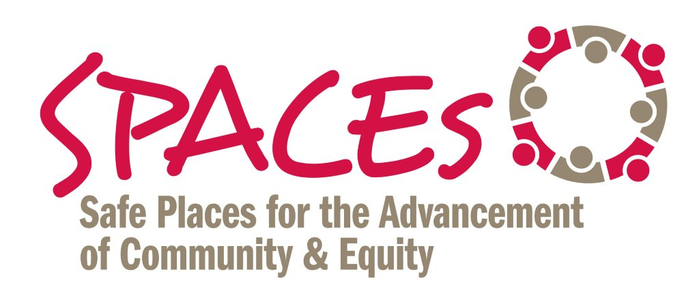

How Do We Reduce/Interrupt Implicit Bias

# 1 -- IMPROVED DECISION-MAKING

Slowing down; being more deliberative; removing discretion and ambiguity from decision-making:

Example: Courts Catalyzing Change “bench card” or checklist for judges. See excerpt below:

- What assumptions have I made about the cultural identity, genders, and background of this family?

- What evidence has supported every conclusion I have drawn, and how have I challenged unsupported assumptions?”

# 2 -- COUNTER-STEREOTYPIC IMAGING

The subconscious power of pictures, images and symbols to create “identity safety” and reduce negative biases.

Example: "I am Jesse Owens" mural in NW Washington, D.C.

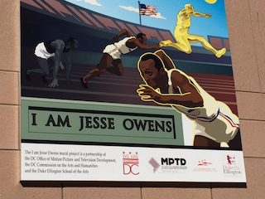

# 3 -- PERSPECTIVE TAKING

Walking in the shoes – taking on the first hand perspective -- of others (or the perceived other)

Examples:

- Federal Judge Mark Bennet spending time in a solitary confinement cell;

- Former Newark Mayor Cory Booker living on food stamps for a week

# 4 -- INDIVIDUATING –

Using the power of regular, one-on-one conversations to see people for their individual qualities and attributes versus seeing them as part of a stereotypic group.

- Church-based organizing networks requiring organizers to conduct 20-35 in person meetings each week

- American Federation of State, City and Municipal Employees (AFSCME) Stronger Together campaign – training 5% of its members to engage another 80% “one conversation at a time.”

# 5 -- INTER-GROUP CONTACT

Using the power of positive, sustained dialogue across different identity groups to support individuation, perspective taking and group re-categorization.

Example -- National Park Service (NPS) Allies for Inclusion Program; training NPS staff to be dialogue facilitators; using 60-90 minute monthly "brown bags" as the strategy.

