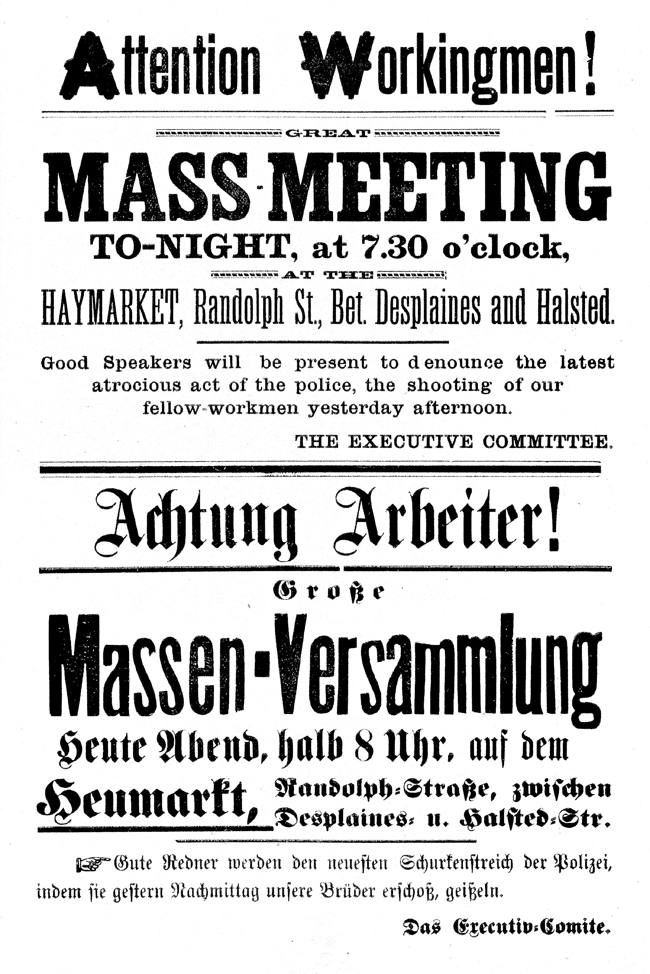

The Haymarket Handbills

A cry for justice, the eight-hour workday, and the pieces of paper from Chicago that ignited the global labor movement.
_______________________________
Join a conversation at the
42nd AFSCME International Convention, Las Vegas,
Labor History Workshop,
July 18, 2016, 2:30-4:30 PM
For more information contact: afscme2910@gmail.com
_________________
Chronology
- May 1, 1886: Workers across the U.S.strike and demonstrate demanding an eight-hour workday.
- May 3: During a strike at McCormick Reaper Works in Chicago demonstrators clash with police, and four strikers are killed
- May 4: Two versions of handbills announcing a mass-meeting to protest the murders the day before are printed in the offices of the Arbeiter-Zeitung, a German-language anarchist labor newspaper and distributed to workers throughout the city. Close to 3,000 workers arrive that evening in the Haymarket Square to hear the speeches. After police break up the gathering by the force of arms, a bomb is detonated in the crowd. One police officer is killed by the blast, and several men, strikers and police officers, die or are wounded in the ensuing violence.
- May 27: Thirty-one men are indicted and 8 men— Albert Parsons, August Spies, Oscar Neebe, Louis Lingg, George Engel, Adolph Fischer, Michael Schwab, Samuel Fielden—are charged as accessories to murder, though any evidence linking them to the crime is lacking.
- July 16: The eight men go to trial.
- August 19: The men are found guilty, and seven are sentenced to death by hanging. The eighth man, Oscar Neebe is given a sentence of 15 years in the penitentiary.
- September 14, 1887: After an appeal is filed, the Illinois Supreme Court upholds the lower court’s ruling. An appeal to the U.S. Supreme Court in November is denied.
- November 10: Louis Lingg commits suicide in prison.
- November 11, 1887: Parsons, Spies, Engel, and Fischer are executed. Their funeral procession is witnessed by over 150,000 people.
- May 1, 1890: Date of demonstration in Paris for an international eight-hour day, “In Commemoration of the Haymarket Martyrs”, which spreads around the world.
- June 26, 1893: Illinois governor John Peter Altgeld pardons Neebe, Fielden, and Schwab.

Verso image from the version of the original handbill approved by August Spies; from the Rare Book and Special Collections Division, Library of Congress

