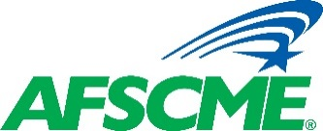________________________________________________________________________________________________
Student Debt Workshop – Learning Lounge

Do you think you’re going to enroll in an IDR plan (please circle one)? Yes No

Do you think you’ll qualify for Public Service Loan Forgiveness (please circle one)? Yes No

Who is your student loan servicer (i.e. Navient/Sallie Mae/etc.)? _____________________________________________________________________________

Would you recommend this workshop to others (please circle one)? Yes No

Name: ______________________________ Affiliate/Local: ________________ State: _____

Phone Number: ________________________ Email__________________________________

Do you have any additional comments?____________________________________________

_____________________________________________________________________________

________________________________________________________________________________________________
Student Debt Workshop – Learning Lounge

Do you think you’re going to enroll in an IDR plan (please circle one)? Yes No

Do you think you’ll qualify for Public Service Loan Forgiveness (please circle one)? Yes No

Who is your student loan servicer (i.e. Navient/Sallie Mae/etc.)? _____________________________________________________________________________

Would you recommend this workshop to others (please circle one)? Yes No

Name: ______________________________ Affiliate/Local: ________________ State: _____

Phone Number: ________________________ Email__________________________________

Do you have any additional comments?____________________________________________

_____________________________________________________________________________

